LAB # 01
INTRODUCTION TO MSP43O MCU AND INSTALLATIONS OF HARDWARE
AND SOFTWARE TOOLS



Spring 2025
CSE-307L

Microprocessor Based System Design Lab

Submitted by: Naveed Ahmad
Registration No.: 22PWCSE2165
Class Section: B

Student Signature: ______________

Submitted to:
Engr. Shah Zada Fahim Jan
March 08, 2025

Department of Computer Systems Engineering
University of Engineering and Technology, Peshawar

Lab Tasks:
Task 1
Write a C Program for MSP-430 which toggle P1.0 or any other pin of MSP-430 MCU Code: 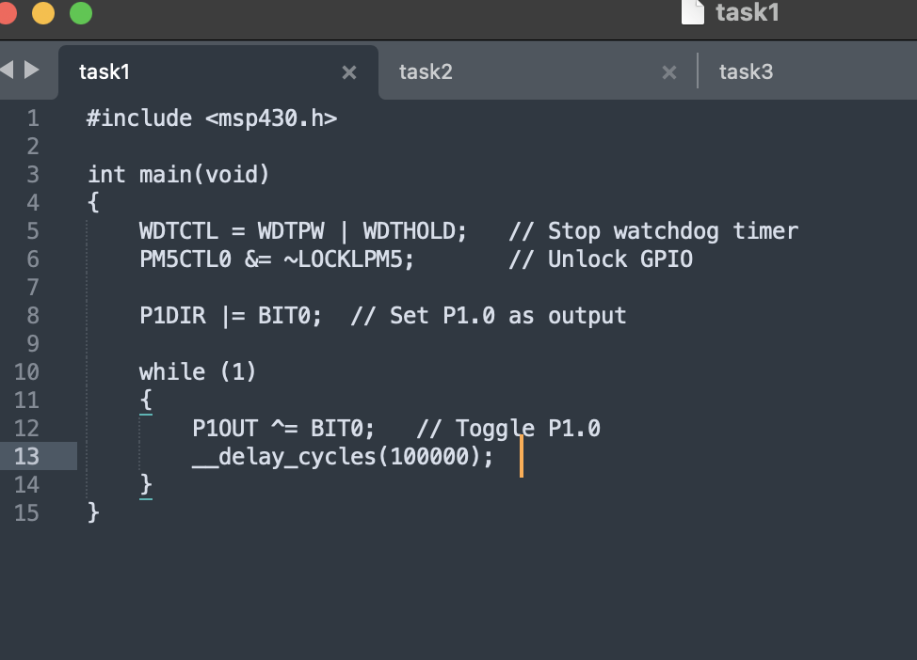

Output:
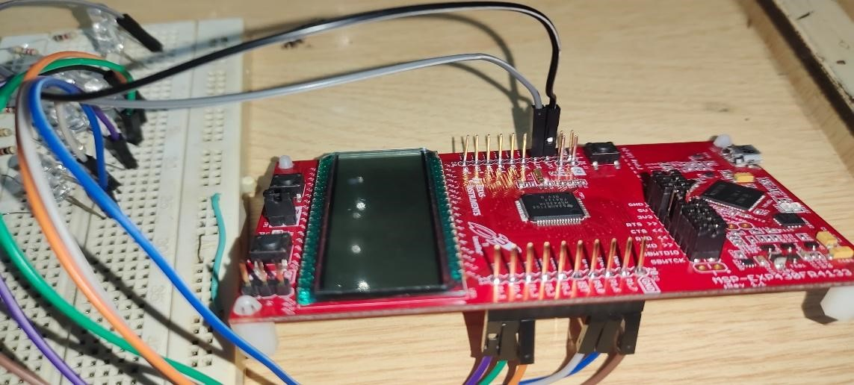

Task 2
Write a C Program for MSP-430 which toggle P4.0 for MSP-430 FR4133 or any other pin of MSP-430 MCU
Code: 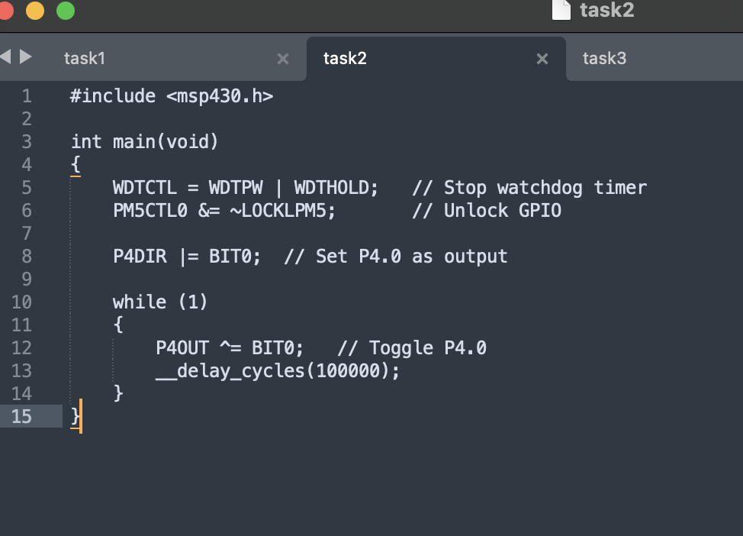

Output:
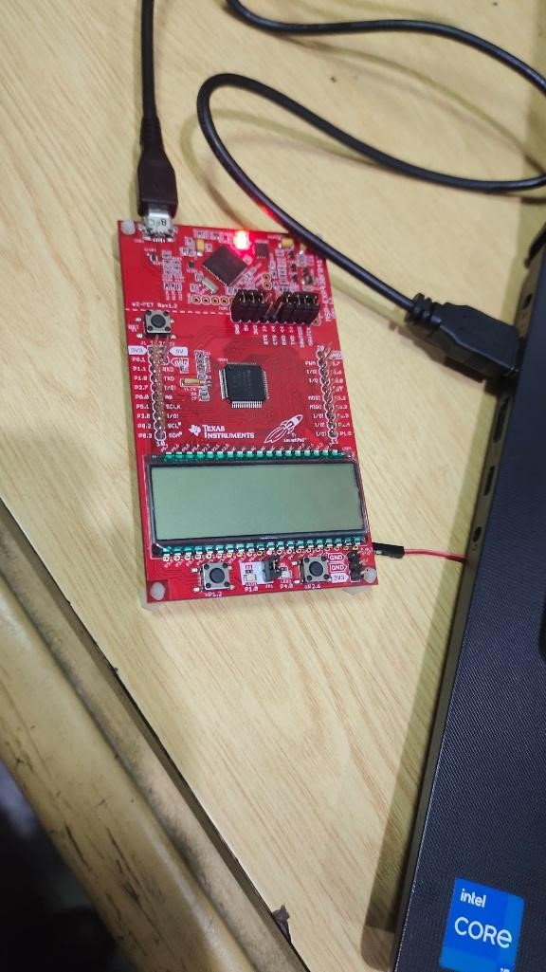
Task 3
Write a C Program for MSP-430 which toggle P5.1 for MSP-430 FR4133 or any other pin of MSP-430 MCU Code:
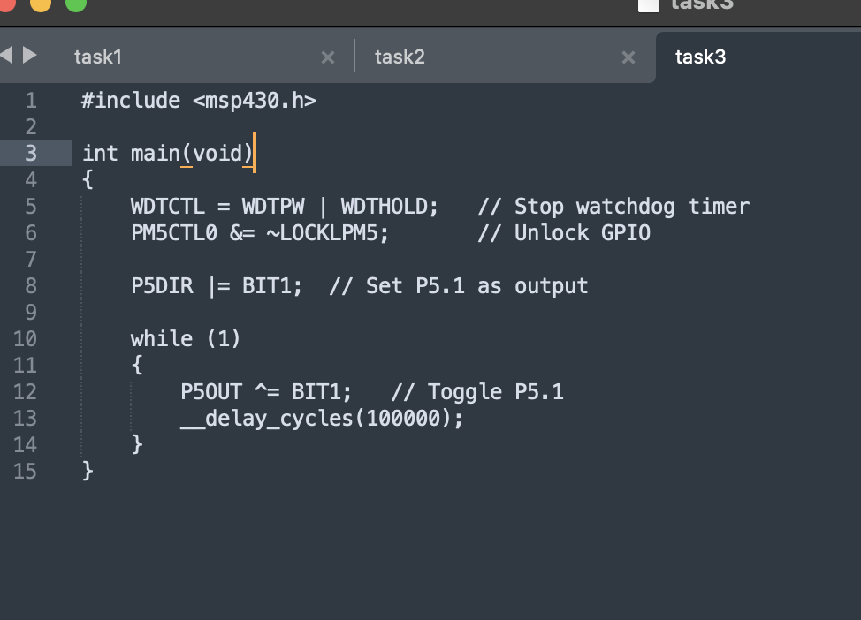

Output:
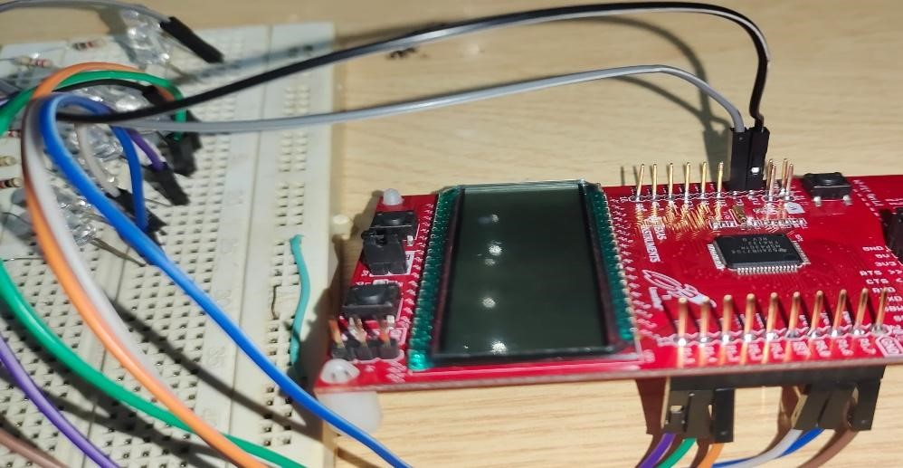

Task 4
Write a C Program for MSP-430 which toggle P1.1 for MSP-430 FR4133 or any other pin of MSP-430 MCU
Code:
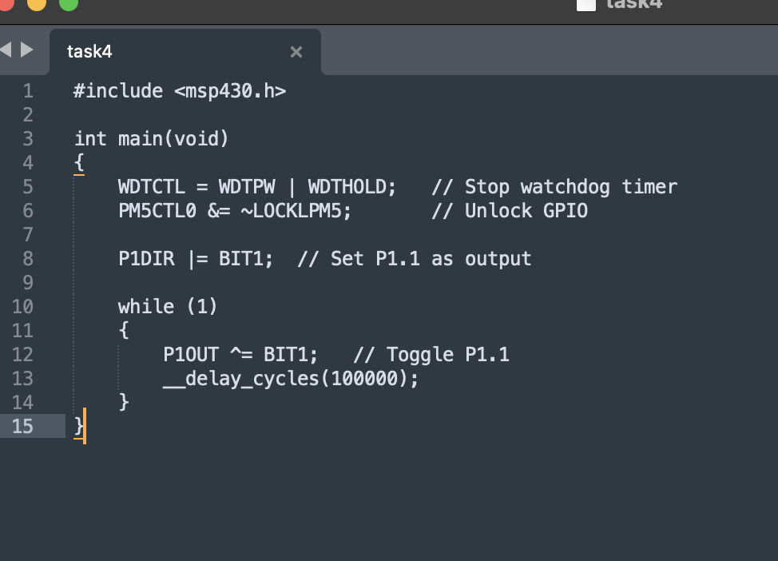
Output:
